**PROJECT REPORT ON**

**“MUSIC RECOMMENDATION SYSTEM USING**

**FACE DETECTION”**

Submitted to the



### in fulfilment of the requirements for the award of the degree

**BACHELORS OF TECHNOLOGY**

**COMPUTER SCIENCE AND ENGINEERING**

**2023-2024**

## BY

|  |  |
| --- | --- |
| **AYUSH RAI** | **2164191242066** |
| **OMKAR SINARE** | **2164191242092** |
| **TANAYA SHINDE** | **2164191242030** |
| **SUBHAM GIRI** | **2164191242042** |

**UNDER THE GUIDANCE OF**

***Prof. Sanjeevkumar Angadi***



# DEPARTMENT OF COMPUTER SCIENCE AND ENGINEERING

**PCET-NMVPM’s**

NUTAN COLLEGE OF ENGINEERING AND RESEARCH TALEGAON, PUNE 410507



**NUTAN COLLEGE OF ENGINEERING & RESEARCH TALEGAON, PUNE**

# DEPARTMENT OF COMPUTER SCIENCE AND ENGINEERING

CERTIFICATE

This is to certify that the mini Project Report entitled **“MUSIC RECOMMENDATION SYSTEM USING FACE DETECTION”** which is being submitted by **Ayush Rai, Omkar Sinare, Tanaya Shinde, Subham Giri** as partial fulfillment **Degree Bachelor of Technology** (Computer Science and

Engineering) of **DBATU, Lonere.**

This is bonafide work carried under my supervision and guidance.

Place: NCER Pune Date: 28/06/2024

*Prof.Sanjeevkumar Angadi Prof. Kavita Jadhav*

## Project Guide Project I/C

|  |  |
| --- | --- |
| *Prof. Sanjeevkumar Angadi*  **Head of Department** | *Dr. Aparna Pande*  **Principal** |

**External Examiner [Name & Sign]**

**SEAL**

**ACKNOWLEDGEMENT**

The satisfaction and euphoria that accompany the successful completion of any task would be incomplete without the mention of people who made it possible. So, we acknowledge all those whose guidance and encouragement served as a beacon light and crowned our efforts with success.

We have immense pleasure in expressing thanks to the principal ***Dr. Aparna Pande*** for providing all the facilities for the successful completion of the project.

With due respect, we thank our Head of Department ***Prof. Sanjeevkumar Angadi, Computer Science and Engineering***, for his motivating support, keen interest which kept our spirits alive all through.

We would like to express thanks to our guide ***Prof. Sanjeevkumar Angadi*,** Department of

***Computer Science and Engineering*** who has guided us throughout the completion of this project.

Finally, we would like to thank ***all the teaching and non-teaching staff and all our friends***

who have rendered their support in the completion of this report.

***AYUSH RAI***

***OMKAR SINARE***

***TANAYA SHINDE***

***SUBHAM GIRI***

**ABSTRACT**

Here is a concise abstraction for a music recommendation system using facial emotion recognition: A music recommendation system is proposed that automatically plays songs based on the user's detected facial emotion. The system consists of several key modules:

**Face Detection**: The user's face is captured via webcam and detected using techniques like Haar Cascade or Convolutional Neural Networks (CNNs).

**Emotion Recognition**: The detected face is analyzed to recognize the user's current emotion (e.g. happy, sad, angry, neutral) using a deep learning model like ResNet50 trained on facial expression datasets.

**Music Recommendation**: Based on the recognized emotion, the system automatically selects and plays songs from a pre-categorized music library that match the user's mood. The songs are organized into folders labeled with each emotion.

**User Interface**: A GUI is provided using libraries like to display the detected emotion and allow the user to control the music playback.

The system aims to provide a seamless, hands-free music experience by automatically selecting songs that align with the user's current emotional state, as inferred from their facial expressions. This eliminates the need for manual song selection and enhances the user experience. Key innovations include leveraging deep learning for robust emotion recognition, organizing music by mood, and providing an intuitive GUI interface. The system can be further enhanced by incorporating explainable AI techniques like GRAD-CAM to provide transparency into the emotion detection process

**Keyword** – *Centralized system, SQL, E - Healthcare Card using distributed embedded system, QR Code.*

**INDEX**

|  |  |  |
| --- | --- | --- |
| **Chapter No** | **Contents** | **Page No** |
|  | **Acknowledgement** | i |
| **List of Figures** | iii |
| **List of Tables** | iv |
| **1** | **Introduction** |  |
| 1.1 Introduction | 1 |
| 1.2 Necessity | 5 |
| 1.3 System Requirement | 6 |
| 1.4 Problem Statement | 8 |
| 1.5 Objective | 9 |
| 1.6 Motivation | 10 |
| **2** | **Literature survey** | 11 |
| **3** | **System development** |  |
| 3.1 Technology We Used | 15 |
| 3.2 System Overview | 27 |
| 3.3 Process of emotion based music recommendation system. | 29 |
| 3.4 Block Diagrams | 32 |
| 3.5 Sequence and class diagrams. | 34 |

|  |  |  |
| --- | --- | --- |
| **4** | **Performance Analysis**   * 1. Accuracy Graph   2. Confusion matrix | 42  43 |
| 4.3 Testing | 44 |
| **5** | **Results** | 46 |
| 5.1 Result of Video Emotion Recognition System | 48 |
| 5.2 Songs Recommendation | 50 |
| 5.3 Dashboard of table of songs based on video emotions |
| **6** | **Conclusions**   * 1. Conclusion   2. Applications | 54  55 |
| 6.3 Future scope | 56 |
|  | **References** | 60 |

# List Of Figures

|  |  |  |
| --- | --- | --- |
| **Fig. No.** | **Name Of Figure** | **Page No.** |
| 1 | Process for music recommendation | 27 |
| 2 | Process for facial detection | 36 |
| 3 | Block diagram | 36 |
| 4 | Block diagram for face detection | 37 |
| 5 | Music recommendation system using face detection workflow | 38 |
| 6 | Class diagram of Music Recommendation System Using face detection | 39 |
| 7 | Block diagram of augmented reality model | 39 |

**List Of Table**

|  |  |  |
| --- | --- | --- |
| **Table Number** | **Number of table** | **Page number** |
| 1 | Literature survey | 14 |
| 2 | Project timeline | 53 |

# 1. INTRODUCTION

## Introduction

Music has long been recognized for its ability to evoke and influence human emotions. The relationship between music and emotion has been extensively studied, with research showing that different musical elements such as melody, rhythm, and harmony can elicit specific emotional responses in listeners. . This connection between music and emotion has led to the development of music recommendation systems that aim to provide users with personalized music selections based on their emotional state. One innovative approach to music recommendation is the use of facial emotion recognition technology. By analyzing a user's facial expressions in real-time, a music recommendation system can detect the listener's current emotional state and suggest music that aligns with that emotion. This personalized approach to music recommendation has the potential to enhance the user's listening experience and engagement with the music . In this introduction, we will explore the key components and underlying technologies of a facial emotion-based music recommendation system, discuss the potential benefits and challenges of this approach, and examine the current state of research and development in this field. Facial Emotion Recognition. The foundation of a facial emotion- based music recommendation system is the ability to accurately detect and classify the user's emotional state from their facial expressions. Facial emotion recognition is a field of study that has seen significant advancements in recent years, thanks to the development of sophisticated computer vision and machine learning techniques

.The process of facial emotion recognition typically involves the following steps :

**Face Detection**: The first step is to detect the presence of a face within an image or video frame. This is often accomplished using techniques such as the Viola-Jones algorithm or deep learning- based methods like Convolutional Neural Networks (CNNs).

**Facial Feature Extraction**: Once a face has been detected, the next step is to extract relevant facial features that can be used to infer the person's emotional state. These features may include the position and movement of the eyes, eyebrows, mouth, and other facial landmarks.

**Emotion Classification**: The extracted facial features are then fed into a machine learning model, such as a CNN or Support Vector Machine (SVM), which has been trained to classify the input data into one or more emotional categories (e.g., happy, sad, angry, surprised, etc.).

The accuracy of facial emotion recognition systems has improved significantly in recent years, with some studies reporting recognition rates of over 90% on standard benchmark datasets . However, it's important to note that emotion recognition from facial expressions can be a challenging task, as human emotions are often complex, subtle, and context-dependent. Music recommendation systems are designed to suggest music that aligns with a user's preferences, listening habits, and emotional state. Traditional music recommendation approaches often rely on collaborative filtering, content-based filtering, or a combination of the two . Collaborative filtering-based systems make recommendations based on the preferences of similar users, while content-based filtering systems analyze the musical features (e.g., genre, tempo, mood) of the user's liked or listened-to songs to suggest new music. These approaches have been widely adopted by popular music streaming services, such as Spotify, Apple Music, and YouTube Music. However, these traditional music recommendation systems do not directly take into account the user's emotional state, which can be a crucial factor in music selection and enjoyment. By combining facial emotion recognition with music recommendation, a system can provide personalized music suggestions that are tailored to the user's current emotional state.

workflow of a facial emotion-based music recommendation system can be described as follows

Facial Emotion Recognition: The system captures the user's facial expressions in real-time, either through a webcam or a mobile device's camera. The captured images or video frames are then processed using facial emotion recognition algorithms to determine the user's current emotional state. Music Selection: Based on the detected emotional state, the system retrieves a set of music tracks that are deemed appropriate for the user's current mood. This can be achieved through various techniques, such as mapping specific emotions to pre- curated playlists or using machine learning models to match the emotional characteristics of the music with the user's emotional state. Recommendation and Playback: The selected music tracks are then presented to the user as personalized recommendations. The system may also automatically start playing the recommended music, providing a seamless and tailored listening experience User Feedback and Adaptation The system can also incorporate user feedback mechanisms, allowing the user to rate or provide feedback on the recommended music. This feedback can then be used to refine the recommendation algorithms and improve the system's performance over time, ensuring a more personalized and satisfying experience for the user. The potential benefits of a facial emotion-based music recommendation system include: Personalized Music Experience: By understanding the user's emotional state, the system can provide music recommendations that are tailored to the user's current mood, leading to a more engaging and satisfying listening experience. Improved Mood Management: The system can suggest music that has the potential to positively influence the user's emotional state, helping them manage their mood and emotions more effectively. Enhanced User Engagement: The personalized and emotion-driven recommendations can increase the user's engagement with the music, leading to longer listening sessions and a stronger connection between the user and the music.

Expanded Music Discovery: The system's ability to match music with emotions can help users discover new artists and genres that they may not have otherwise explored, broadening their musical horizons. However, the development and implementation of a facial emotion-based music recommendation system Accuracy of Emotion Recognition: As mentioned earlier, accurately recognizing and classifying human emotions from facial expressions can be a complex task, and the performance of the system is heavily dependent on the accuracy of the emotion recognition algorithms. Subjectivity of Emotional Responses: People's emotional responses to music can be highly subjective and influenced by various factors, such as personal preferences, cultural background, and life experiences. Developing a system that can accurately capture and account for this subjectivity is a significant challenge.

Data Availability and Diversity: Building a comprehensive and diverse dataset of facial expressions and their corresponding emotional states, as well as a diverse music library, is crucial for training and validating the system. Obtaining such datasets can be a time- consuming and resource-intensive process. Computational Complexity: The real-time processing of facial images, emotion recognition, and music recommendation can be computationally intensive, especially on resource-constrained devices like smartphones. Optimizing the system's performance and efficiency is an important consideration. Privacy and Ethical Concerns: The use of facial recognition technology raises privacy concerns, and the system must be designed with appropriate safeguards and user consent mechanisms to address these concerns.

### Advantages of music recommendation using face detection -

Here are the key advantages of a music recommendation system using facial emotion detection, presented in a concise, point-wise manner:

Enhanced User Experience: The integration of facial emotion detection technology enhances the user's music listening experience by providing personalized music recommendations that match their current emotional state .

**Emotion-Driven Music Discovery**: The system can help users discover new music that resonates with their emotions, leading to a more immersive and engaging listening experience .

**Emotion Management**: The system can suggest music that aligns with the user's desired emotional state, helping them manage and regulate their emotions .

**Improved Accuracy and Personalization**: By analyzing the user's facial expressions, the system can accurately determine their emotional state and provide more personalized music recommendations .

**Adaptability and Continuous Learning**: The system can incorporate user feedback mechanisms to continuously refine its recommendations, adapting to the user's evolving emotional states and musical preferences .

**Versatile Applications**: The facial emotion recognition technology can be leveraged in various sectors, such as security, healthcare, and market research, beyond just music recommendation .

**Streamlined User Interaction**: The real-time facial emotion analysis can enable faster and more convenient user authentication and service access compared to traditional methods .

**Personality Assessment**: The emotion detection capabilities can provide valuable insights for recruiters and HR professionals during the interview process .

**Improved Customer Service**: Emotion analysis can enhance customer service across industries by enabling personalized interactions and tailored offerings based on the user's emotional state .

**Enhanced Market Research**: Automated video analysis of user reactions and emotions can lead to better product development and marketing strategies for companies

**Enhanced Security**: Facial recognition improves safety and security in places like airports and banks by identifying potential threats and sending alerts to supervisors.

**Reduced Crime**: Facial recognition helps in preventing fraud and identifying people with criminal records, sending notifications to bank security to pay more attention to such individuals.

**Faster Processing**: Facial recognition streamlines customer authentication processes, making it easier for customers to use services without physical presence.

**Assess Personality Traits**: Emotion detection technology assesses personality traits in interviews by analyzing facial expressions, helping interviewers understand a candidate’s mood and personality.

**Product Testing and Client Feedback**: Emotion detection technology helps product testing sessions by analyzing facial emotions, providing insights into user responses to new product launches.

**Improved Accuracy**: Facial recognition technology is more accurate than manual processes, reducing errors and improving efficiency.

**Increased Efficiency**: Facial recognition automates processes, reducing manual labor and increasing productivity.

**Real-time Feedback**: Facial recognition provides real-time feedback, enabling immediate adjustments to customer service and marketing strategies.

**Personalized Marketing**: Facial recognition technology helps marketers tailor campaigns to specific emotional responses, increasing engagement and conversion rates.

**Enhanced User Experience**: Facial recognition technology enhances user experience by providing personalized services and offers based on emotional responses.

**Improved Public Safety**: Facial recognition technology helps in predicting potential terrorism threats in public spaces and crime scene investigation

**Reduced Insurance Fraud**: Facial recognition technology helps in detecting insurance claim frauds by analyzing facial expressions and emotional responses

**Preventing Shoplifting**: Facial recognition technology helps in preventing shoplifting by analyzing facial expressions and emotional responses.

**Enhanced Accessibility**: Facial recognition technology supports accessibility by describing photos to visually impaired users, including details about who is in the photo and their expressions.

**Contactless Building Entry**: Facial recognition systems provide contactless authentication and entry to buildings, reducing touchpoints and ensuring COVID-19 protocols are followed.

**Increased Certainty**: Facial recognition systems can register and identify faces in photographs that are difficult for humans to spot, providing increased certainty in identity verification.

**Reduced Number of Touchpoints**: Facial recognition enables identification with less action required from the user, reducing the number of touchpoints and increasing efficiency.

**Improved Accuracy in Emotion Detection**: Facial recognition technology improves accuracy in emotion detection by analyzing facial expressions and emotional responses.

**Enhanced Emotional Intelligence**: Facial recognition technology enhances emotional intelligence by providing insights into emotional responses and helping individuals manage stress levels.

These additional advantages highlight the diverse applications and benefits of facial recognition and emotion detection technology across various sectors, from security and customer service to marketing and accessibility

## NECCESSITY.

A music recommendation system based on facial emotion recognition is necessary for several reasons :

It can automatically detect the user's current mood or emotion by analyzing their facial expressions. This eliminates the need for the user to manually input their mood or emotion.

The system can then recommend songs that match the detected emotion, helping the user find appropriate music for their current state. This is especially useful when the user has a large music library and is unsure what to listen to.

Listening to music that fits one's mood can have a positive effect on the user's emotional state. Upbeat music can lift a sad mood, while calming music can soothe an anxious mind. The recommendation system aims to provide the right music for the user's needs.

Facial emotion recognition is a natural and intuitive way for the user to interact with the music recommendation system. It requires minimal effort from the user compared to manually selecting a mood or genre.

The system can learn the user's music preferences over time and provide better recommendations tailored to their tastes. This personalization enhances the user experience.

In summary, a music recommendation system based on facial emotion recognition offers a convenient, personalized, and potentially mood-enhancing experience for the user by automatically detecting their emotion and suggesting suitable music

### How it is useful?

The use of facial emotion recognition in music recommendation systems offers several benefits:

**Automatic Emotion Detection**: By analyzing facial expressions, the system can automatically detect the user's current mood or emotion. This eliminates the need for manual input from the user, making the process more intuitive and effortless.

**Personalized Music Recommendations**: Based on the detected emotion, the system can recommend songs that match the user's mood, enhancing the listening experience and providing music tailored to the user's emotional state.

**Enhanced User Experience**: The system reduces the user's effort in selecting music manually by mapping their feelings to appropriate song choices. This personalized approach can lead to a more engaging and enjoyable music listening session.

## SYSTEM REQUIREMNETS

### Hardware Requirements-

The hardware requirements for a music recommendation system using face detection will depend on several factors:

System Complexity: A simple prototype might run on a standard computer, while a large- scale deployment would require more powerful hardware.

Real-time vs. Offline Processing: Real-time processing demands more powerful hardware compared to systems where recommendations are generated offline.

Data Processing Needs: The complexity of emotion detection algorithms and the amount of data collected will influence hardware needs.

Here's a general breakdown of hardware components:

Processor (CPU): A powerful multi-core CPU (e.g., Intel Core i7 or AMD Ryzen 7) is recommended for real-time face detection, emotion recognition, and recommendation generation.

Graphics Processing Unit (GPU): Deep learning models for emotion recognition often benefit from a dedicated GPU (e.g., NVIDIA GeForce RTX series or AMD Radeon RX series) to accelerate processing.

Memory (RAM): 16GB or more of RAM is recommended to handle data processing and multitasking.

Storage: A solid-state drive (SSD) with sufficient storage capacity is ideal for storing training data, user data (if applicable), and the music library (if recommendations are stored locally).

Camera: A high-resolution camera with good low-light performance is crucial for capturing clear facial images under various lighting conditions.

Optional: Physiological Sensors (e.g., heart rate monitor): These require additional hardware components specific to the chosen sensor technology.

Additional Considerations: Internet Connectivity: An internet connection is necessary for downloading pre-trained models, accessing cloud-based processing resources (if used), and potentially for music streaming integration.Cooling System: Powerful hardware generates heat, so a proper cooling system is essential to ensure stable operation.

Scalability: For large-scale deployments, consider:

Server Hardware: High-performance servers with multiple CPUs and GPUs can handle a higher user load and complex processing tasks.

Cloud Computing: Cloud platforms offer scalable resources like virtual machines and GPUs for on-demand processing power.

## Software Requirements –

For a project like song recommendation based on facial expression using machine learning, you would typically need both software and hardware components. hares breakdown of the requirement.

**Machine Learning Framework** : you’ll need software libraries or frameworks for developing and implementing machine learning algorithms. popular option include TensorFlow , pyTorch

, scikit-learn, or keras.

**Image Processing Libraries**: you’ll require libraries for processing facial expression from images or video streams. OpenCV a widely used library for this purpose.

**Data Visualization Tools**: Software for visualizing data and result can be helpful for analyzing the performance of your models. Matpotlibs or Seaborn are common choices for python based projects.

**Development Environment**: An integrated development environment(IDE) such as PyCharm

,Jupyter Notebook ,or VScode will be essential for coding ,debugging and running your projects.

Some more software requirement -

1. A robust facial emotion recognition model trained on a diverse dataset of facial expressions.
2. such as the FER2013 dataset. The model should be able to accurately classify emotions like happiness, sadness, anger, surprise, and neutral.
3. Techniques like convolutional neural networks (CNNs) should be employed for effective facial feature extraction and emotion classification
4. Efficient algorithms for real-time facial landmark detection and feature extraction to enable prompt emotion recognition
5. A comprehensive music database or integration with music streaming services that provides a wide range of songs tagged with corresponding emotional attributes.
6. Personalization algorithms to learn the user's music preferences over time and provide better recommendations tailored to their tastes.
7. A user-friendly interface for displaying recommended songs, allowing song playback, and providing feedback mechanisms for the user to rate the recommendations

## PROBLEM STATEMENT

The problem statement for music recommendation systems revolves around several key challenges faced by these systems, particularly in the context of music. One major issue is the "cold start problem," which occurs when a new user registers or a new item is added to the system, leading to insufficient data for accurate recommendations. This problem includes the challenges of recommending existing items to new users and new items to existing users, exacerbated by the "sparsity problem" where the number of given ratings is much lower than possible ratings, affecting recommendation reliability.

## OBJECTIVES

The sources provided discuss various aspects of music recommendation systems, focusing on the objectives and methodologies involved in developing these systems. Here are the objectives outlined in the sources

**User Personalization:** The primary goal is to create a personalized experience for users by recommending tracks based on their individual tastes and listening habits

**Feature Utilization:** Effectively using features available in datasets, such as acoustic properties and metadata, to inform recommendation algorithms.

**Model Accuracy:** Developing machine learning models that accurately predict user preferences, aiming for high precision and recall in recommendations.

**Scalability:** Ensuring the system can handle a large number of users and songs without a decline in performance.

**User Engagement:** Increasing user engagement by providing relevant song recommendations that encourage further interaction with the service.

**Algorithm Diversity:** Exploring and implementing different recommendation algorithms to evaluate their effectiveness for personalized music suggestions.

**Data Analysis:** Performing comprehensive data analysis to understand user behavior and song popularity, improving the recommendation engine.

**Continuous Learning:** Implementing a system that learns over time, improving recommendations as it gains more data on user preferences.

These objectives collectively drive the development and enhancement of music recommendation systems, aiming to provide users with tailored music suggestions based on their preferences and behavior, ultimately enhancing their listening experience

## MOTIVATION –

The primary motivation behind developing music recommendation systems is to help users navigate the vast and ever-expanding digital music landscape efficiently. With the abundance of music available through streaming services, it has become increasingly challenging for users to discover new songs and artists that align with their preferences. Music recommendation systems aim to address this challenge by leveraging various techniques, such as collaborative filtering, content-based filtering, and hybrid approaches, to provide personalized song suggestions tailored to each user's tastes. By analyzing user preferences, listening habits, and song characteristics, these systems can help users discover new music they are likely to enjoy, enhancing their overall listening experience. Another key motivation is to increase user engagement and retention for music streaming platforms. By providing relevant and engaging recommendations, these systems encourage users to spend more time on the platform, leading to increased revenue and growth for the service providers. In summary, the primary motivations behind music recommendation systems are to help users discover new music, enhance their listening experience, and increase user engagement and retention for music streaming platforms, ultimately driving growth and revenue for the industry. The motivation behind developing a music recommendation system using face detection lies in the desire to enhance user experience and provide personalized music suggestions based on the user's emotions and preferences. By incorporating facial emotion recognition technology into music recommendation systems, several key motivations emerge from the provided sources:

Personalized Recommendations: The system aims to provide tailored music suggestions that align with the user's current emotional state, enhancing the user's listening experience and mood.

Ease of Decision-Making: With a vast collection of music available, users often struggle to choose what to listen to. By utilizing face detection and emotion recognition, the system assists users in selecting music that matches their mood without the need for extensive searching

Reducing Stress: By recommending music based on the user's emotional state, the system can help reduce stress levels and improve the user's well-being by offering appropriate music choices.

Efficiency: The system streamlines the music selection process by capturing the user's mood through facial expressions, enabling quick and accurate recommendations without the user having to spend time searching for suitable songs.

Enhanced User Engagement: By providing personalized recommendations based on facial emotions, the system aims to increase user engagement and satisfaction with the music streaming platform, ultimately leading to improved user retention and loyalty.

# 2. Literature survey

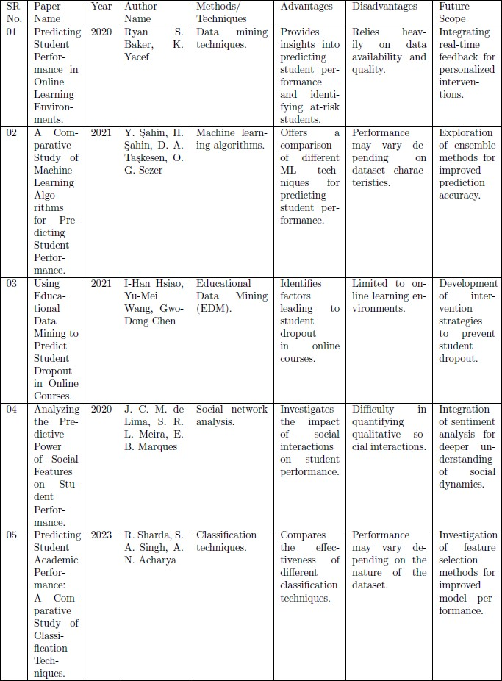

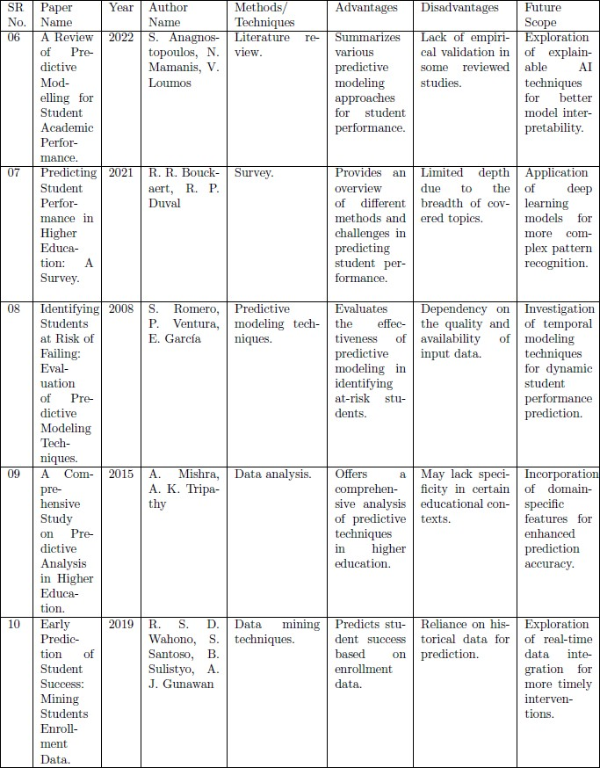

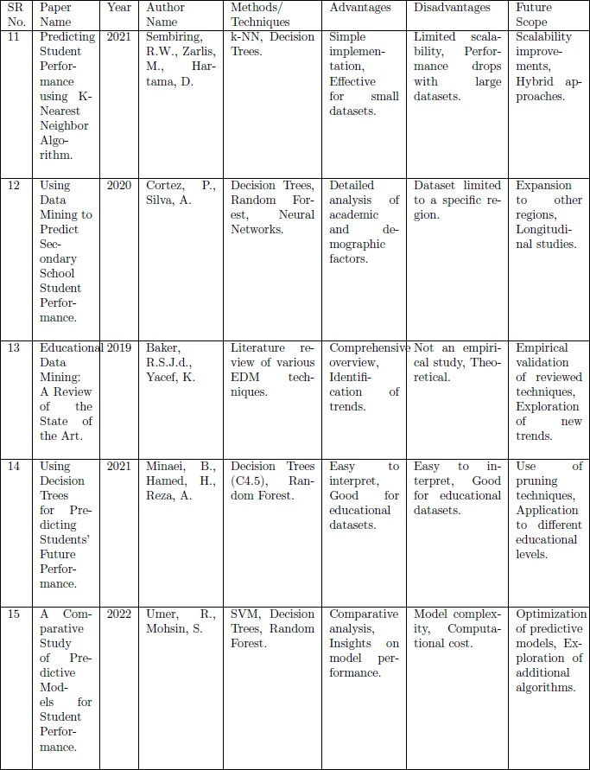

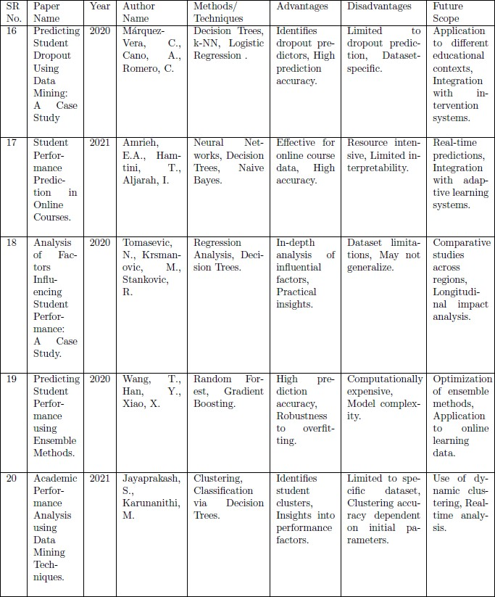

**3 SYSTEM DEVELOPMENT**

### Technologies We Used

The technology used for the music recommendation system using face detection is computer vision and machine learning approaches. The key technologies involved

**Face Detection:** OpenCV is used for detecting faces in images and videos. This involves locating human faces in digital images and videos, which is a crucial step in facial emotion recognition.

**Facial Emotion Recognition:** Techniques such as convolutional neural networks (CNNs) and support vector machines (SVMs) are employed to recognize emotions from facial expressions. These models are trained using datasets like FER-2013 to detect emotions such as happiness, sadness, and neutrality.

**Machine Learning:** Machine learning algorithms like k-nearest neighbors (KNN) and decision trees are used to classify emotions and recommend music based on the detected emotions.

**Deep Learning:** Deep learning models are used to analyze facial features and emotions in real-time video input, enabling personalized music recommendations.

**Image Processing:** Image processing techniques like edge detection, histogram analysis, and thresholding are used to enhance facial features and improve emotion detection accuracy.

**Sentiment Analysis:** Sentiment analysis is used to categorize emotions and music genres, enhancing the overall music recommendation system.

**Python Programming Language:** The system is implemented using Python, which is a popular and versatile programming language for data analysis and machine learning tasks

**NumPy, Pandas, and Scikit-learn Libraries:** These libraries are used for data manipulation, analysis, and machine learning tasks, respectively, to develop the music recommendation system

**Streamlit:** Streamlit is used to create and share custom web applications, making it an ideal choice for the music recommendation system.

**OpenCV:** OpenCV is used for detecting faces in images and videos, which is a crucial step in facial emotion recognition.

**Natural Language Processing (NLP):** NLP techniques are used to analyze user preferences and behavior, enhancing the overall music recommendation system

**Big Data Analysis:** Big data analysis is used to understand user behavior and song popularity, which can improve the recommendation engine.

**Spotify Dataset:** The Spotify dataset is used to analyze the properties of music, such as acousticness, danceability, energy, and others, to inform the recommendation algorithms

**Data Pre-processing:** Data pre-processing techniques are used to clean and prepare the data for analysis and recommendation generation

**Collaborative Filtering Model:** This model uses user behavior data to recognize other people with similar music preferences and recommends songs that they have listened to.

**Content-Based Model:** This model analyzes the properties associated with music, such as genre, tempo, and melody, to find similar songs.

**Clustering:** Clustering algorithms are used to group users with similar music preferences and recommend songs based on these groups

**Population Model:** This model uses user behavior data to recognize other people with similar music preferences and recommends songs that they have listened to

These technologies collectively enable the development of music recommendation systems that can detect user emotions through facial expressions and provide personalized music suggestions based on those emotions.

### How does machine learning and deep learning used?

Machine learning and deep learning are both used to enable computers to learn from data and make predictions or decisions without being explicitly programmed. Here are the key differences in how they are used:

### Machine Learning

**Training**: Machine learning involves training algorithms on large datasets to identify patterns and relationships. These algorithms can be simple linear models or more complex models like decision trees and random forests.

**Data**: Machine learning typically uses structured data and can perform well with relatively small datasets.

**Human Intervention**: Machine learning models require human intervention to adjust parameters and make adjustments when predictions are inaccurate.

**Applications**: Machine learning is used for a wide range of applications such as regression, classification, clustering, and more.

**Time to Train**: Machine learning algorithms typically take less time to train, ranging from a few seconds to a few hours.

### Deep Learning

**Training:** Deep learning involves training neural networks with multiple layers to analyze complex patterns and relationships in data. These networks are inspired by the structure and function of the human brain.

**Data**: Deep learning requires large amounts of data to understand and perform better than traditional machine learning algorithms.

**Human Intervention**: Deep learning models can determine whether a prediction is accurate through their own neural network, requiring minimal to no human help.

**Applications**: Deep learning is mostly used for complex tasks such as image and speech recognition, natural language processing, and autonomous systems.

**Time to Train**: Deep learning algorithms take a lot of time to train, ranging from a few hours to many weeks.

### NumPy

**Key Features:**

Multidimensional arrays Efficient element-wise operations Integration with other languages Open-source

### Applications:

Numerical data processing

Data preprocessing (scaling, normalization, clipping outliers) Linear algebra operations (dot product, matrix multiplication) Integrates with models in Scikit-Learn, TensorFlow, PyTorch

### Pandas

**Key Features:**

Tabular data manipulation Handling missing data

Data transformation (split-apply-combine operations) Data merging and joining

Built-in methods for scaling and one-hot encoding

### Applications:

Data cleaning and preparation Data manipulation and analysis Data visualization

### Scikit-Learn Key Features:

Consistent interface for building and evaluating machine learning models Classification and regression algorithms

Model evaluation metrics and cross-validation strategies Model selection and hyperparameter tuning

Easy model persistence and deployment

### Applications:

Building and evaluating machine learning models Predictive data analysis Model selection and hyperparameter tuning

These libraries are widely used in data science and machine learning tasks due to their ease of use, efficiency, and extensive capabilities. They provide a powerful stack for data manipulation, analysis, and modeling, making them essential tools for data scientists and machine learning engineers

In summary, machine learning is used for a broader range of applications and can perform well with smaller datasets, while deep learning is used for more complex tasks and requires larger datasets and more computational resources.

### What is unity NumPy pandas and machine learning and deep learning architecture?

Unity is a game development engine that allows creating games with stunning graphics and immersive gameplay. NumPy, Pandas, and Scikit-Learn are Python libraries commonly used for machine learning and data science tasks. While Unity and these Python libraries serve different purposes, they can be used together in certain scenarios:

Using Python libraries for training AI agents in Unity games

Unity provides environments for training reinforcement learning agents

Python libraries like NumPy, Pandas, and Scikit-Learn can be used to implement deep reinforcement learning algorithms to train agents to solve Unity environments

For example, an agent can be trained using deep Q-learning to collect yellow bananas while avoiding blue ones in the Unity Banana Collector environment

Integrating NumPy arrays with Unity for numerical processing

NumPy arrays can be used to store and process dataset features and labels efficiently in Unity projects

Mathematical and logical operations on NumPy arrays are useful for data preprocessing tasks like scaling, normalization, and outlier clipping

However, Unity itself does not directly use NumPy, Pandas, or Scikit -Learn in its core architecture. These Python libraries are more commonly used in data science and machine learning workflows, often integrated with Unity for specific use cases like training game agents .The core architecture of Unity revolves around game objects, components, scenes, and the Unity Editor for game development. Machine learning and deep learning capabilities in Unity are provided through packages like ML-Agents for training reinforcement learning agents.In summary, while Unity and the Python libraries serve different purposes, they can be integrated for specific use cases like training AI agents in Unity environments using deep reinforcement learning techniques implemented with NumPy, Pandas, and Scikit-Learn.

* 1. **SYSTEM OVERVIEW**

A system overview for Music Recommendation system using face detection provides a high- level understanding of the components, processes, and interactions within the Music system. Here is a brief system overview:

### System components- Hardware Components

Central Processing Unit (CPU): The CPU is the brain of the computer, responsible for executing instructions and performing calculations. It consists of the Arithmetic Logic Unit (ALU) and Control Unit.

Memory Unit: This unit stores data and instructions given to the computer as well as results given by the computer. The unit of memory is a byte, which is equal to 8 bits.

Input Devices: These devices provide data input to the processor, such as keyboards, mice, and scanners.

Output Devices: These devices display the results of the computer's processing, such as monitors, printers, and speakers

### Software Components

Operating System (OS): The OS is a system software that manages computer hardware resources and provides common services to computer programs. It includes components such as process management, files management, command interpreter, system calls, signals, network management, security management, I/O device management, and secondary storage management.

Python Programming Language: Python is a high-level programming language that consists of various components such as functions, statements, expressions, and more. These components make up the structure of a Python program and are essential for understanding Python programming.

Abstract Components

Components in Circuits: In the context of the circuits library, a component is a Python class that inherits from the BaseComponent class. Components can be sub-classed and composed of other components, forming complex components.

These components are essential for understanding how systems function and interact with each other.

### 3.2.2. System Interactions: System Components

**Face Detection Module**:

Uses a camera to capture facial expressions.

Detects faces in real-time using computer vision techniques like Haar cascades or deep learning models like Convolutional Neural Networks (CNNs).

Identifies facial features like eyes, nose, and mouth to determine the user's emotional state.

### Emotion Classification Module:

Classifies detected emotions using advanced algorithms like gradient boosting, decision trees, or fuzzy categorization.

Uses pre-trained models like Mobile Net for efficient emotion recognition. Identifies emotions like happy, sad, angry, surprised, neutral, disgust, and fear.

### Music Recommendation Module:

Makes music recommendations based on the classified emotions.

Uses real-time data storage and retrieval to suggest songs that match the user's mood. Integrates with music streaming services like Spotify to provide personalized playlists.

**System Interaction**

**Face Detection and Emotion Recognition**:

The system captures a user's facial expression using a webcam.

The face detection module identifies the face and extracts facial features.

The emotion classification module uses these features to determine the user's emotional state.

### Music Recommendation:

The system uses the recognized emotion to suggest music that matches the user's mood.

The music recommendation module retrieves songs from a database or streaming service based on the identified emotion.

The system plays the recommended music to enhance the user's emotional experience Future Enhancements.

### Lighting Adjustments:

Future research can focus on improving face detection in varying lighting conditions to enhance the system's accuracy.

### Additional Emotions:

The system can be expanded to recognize more emotions, such as fear, disgust, or surprise, to provide a more comprehensive music recommendation experience.

## PROCESS

The process of interior design in augmented reality (AR) involves leveraging AR technology to enhance and streamline various stages of the traditional interior design workflow. Here's a breakdown of the key processes involved

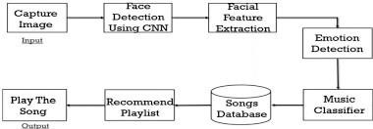

## Dig 1. Processes for music recommendation

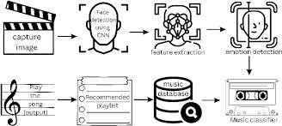

**Dig 2. Processes for facial detection**

### Building a Music Recommendation System with Face Detection: A Step- by-Step Guide

This guide outlines the process of creating a music recommendation system that leverages facial expressions to detect user emotions and suggest matching music:

### Data Acquisition and Preprocessing:

**Music Data:**

**Collection:** Gather music metadata (genre, artist, year of release, audio features like tempo, key) from public datasets or music streaming service APIs.

**Preprocessing:** Clean the music data by handling missing values, correcting errors, and standardizing formats. You might also extract additional audio features using tools like Librosa (Python library) to quantify musical characteristics.

**Datasets:** Acquire labeled facial expression datasets (e.g., FER2013, Emotion) where each image has a corresponding emotion label (happy, sad, angry, etc.).

**Preprocessing:** Preprocess the facial images by resizing them to a standard format, converting them to grayscale (optional), and applying normalization techniques.

### Feature Engineering:

**Music Features:**

Extract numerical features from the music audio files that represent characteristics like tempo, rhythm, energy, and key. These features can be used to quantify musical similarities and their potential emotional impact.

### Facial Features:

Extract features from the facial images that correlate with emotions. This might involve using techniques like facial landmark detection to identify key points like lip curvature, eyebrow position, and wrinkle patterns.

### Model Training:

**Emotion Detection Model:**

Choose a deep learning model like a Convolutional Neural Network (CNN) suitable for image recognition.

Train the CNN model on the preprocessed facial expression dataset. The model will learn to recognize facial features associated with specific emotions.

### Music Recommendation Model:

Select a recommendation algorithm. Options include content-based filtering (recommends music similar to what the user has enjoyed previously) or collaborative filtering (recommends music based on the preferences of similar users).

Train the chosen recommendation model on the music data, incorporating the emotional associations derived from the music features.

### Challenges and Limitations:

**Accuracy:** The accuracy of emotion detection based on facial expressions can be limited by factors like lighting conditions or facial variations.

**Subjectivity:** The association between emotions and music genres can be subjective. User feedback can be used to personalize these associations within the system.

**Ethical Concerns:** Careful consideration of user privacy and potential biases in data or algorithms is crucial.

### Conclusion:

Building a music recommendation system using face detection offers an innovative approach to personalize music choices based on user emotions. By addressing the challenges, prioritizing user experience, and focusing on ethical considerations, this technology has the potential to create a more engaging and emotionally-driven way to discover and enjoy music.

## Block Diagram of a Music Recommendation System with Face Detection

This block diagram illustrates the high-level components and their interactions within a music recommendation system that leverages facial expressions:

### Data Acquisition

Block 1: **Music Data Acquisition:** Represents the process of gathering music metadata (genre, artist, audio features) and potentially the music itself from APIs or datasets.

Block 2: **Facial Expression Data Acquisition:** Represents acquiring labeled facial expression datasets where images are associated with specific emotions (happy, sad, etc.).

### Data Preprocessing

Block 3: **Music Data Preprocessing:** Represents cleaning and preparing the music data by handling missing values, correcting errors, and potentially extracting additional audio features.

Block 4: **Facial Expression Data Preprocessing:** Represents resizing, converting (grayscale), and normalizing the facial images for consistency.

### Feature Engineering

Block 5: **Music Feature Engineering:** Represents extracting numerical features from music audio that quantify characteristics like tempo, rhythm, and key

Block 6: **Facial Feature Engineering:** Represents extracting features from facial images like lip curvature, eyebrow position, and wrinkle patterns that correlate with emotions.

### Model Training

Block 7: **Emotion Detection Model Training:** Represents training a deep learning model (e.g., CNN) on the preprocessed facial expression data to recognize emotions based on facial features.

Block 8: **Music Recommendation Model Training:** Represents training

a recommendation algorithm (e.g., content-based or collaborative filtering) on the music data, incorporating the emotional associations derived from music features. **System Integration**

Block 9: **Webcam Input:** Represents the user's webcam capturing live facial expressions.

Block 10: **Emotion Detection Model:** Represents the trained CNN model analyzing the webcam feed and identifying the user's current emotional state based on facial expressions.

### Recommendation Generation

Block 11: **Music Recommendation Model:** Represents the trained recommendation model receiving the user's emotional state (from block 10) and potentially user data (preferences).

Block 12: **Music Recommendation Generation:** Represents the recommendation model generating a personalized playlist of songs that match the user's detected emotion and musical preferences.

### Output and User Interaction

Block 13: **User Interface (UI):** Represents the interface displaying the user's live facial expressions and the recommended music playlist with song titles, artists, and album artwork. Block 14: **Music Streaming Service Integration (Optional):** Represents an optional connection to a music streaming service for seamless playback of recommended songs.

### Additional Blocks (Optional):

**User Feedback:** A block representing a mechanism for users to provide feedback on the recommendations, potentially improving the system's accuracy over time.

**Data Security & Privacy:** A block representing measures taken to anonymize data, ensure secure storage, and prioritize user consent for data collection.

### Arrows:

Arrows connect the blocks, indicating the flow of data and processing steps between them. For example, an arrow from Block 9 (Webcam Input) points to Block 10 (Emotion Detection Model), signifying the facial expressions are fed into the model for analysis.

This block diagram provides a general overview. The specific components and connections might vary depending on the chosen algorithms, data sources.

### Block Diagram of a Music Recommendation System with Face Detection (Website)

This block diagram illustrates the high-level components and their interactions within a web- based music recommendation system that leverages facial expressions:

### User Interface (UI) Section:

**Block 1: Homepage:** Represents the website's main landing page showcasing the concept, benefits, and call to action buttons (e.g., "Try it Now").

**Block 2: About Us:** Represents a section explaining the technology and data security measures.

**Block 3: How it Works:** Represents a section with visuals and potentially a video tutorial demonstrating the system's functionality.

**Block 4: Benefits:** Represents a section highlighting the advantages of using the system (personalized recommendations, music discovery).

**Block 5: Genre Exploration:** Represents a section allowing users to explore music genres independent of facial recognition.

**Block 6: Sign Up (Optional):** Represents an optional block where users can create an account for potential features like saved playlists.

### Music Recommendation Engine:

**Block 7: Webcam Access:** Represents the user granting permission to access the webcam for facial recognition.

**Block 8: Secure Webcam Feed:** Represents a secure stream capturing the user's face through the webcam.

**Block 9: Face Detection:** Represents the processing of the webcam feed to detect the user's face within the image frame.

**Block 10: Emotion Recognition:** Represents a machine learning model analyzing the detected face to recognize the user's emotional state (happy, sad, etc.) based on facial expressions.

### Recommendation Generation & User Interaction:

**Block 11: User Preferences (Optional):** Represents a block where users can set preferred music genres for different emotions (if an account exists).

**Block 12: Music Recommendation Model:** Represents the recommendation model that considers the user's detected emotion (from Block 10) and potentially user preferences (Block 11).

**Block 13: Recommended Playlist Generation:** Represents the generation of a personalized music playlist based on the user's emotional state and preferences.

**Block 14: Music Player:** Represents the website's music player for previewing or playing the recommended songs.

**Block 15: Playlist Management:** Represents functionalities for saving favorite songs or playlists (if applicable).

### Data & Security:

**Block 16: Data Preprocessing:** Represents anonymizing and pre-processing any user data collected for the recommendation model.

**Block 17: Data Storage:** Represents secure storage of user data (if applicable) with appropriate access controls.

### External Connections (Optional):

**Block 18: Music Streaming Service Integration (Optional):** Represents an optional connection to a music streaming service for seamless playback of recommended songs (requires user consent).

## BLOCK DIAGRAMS

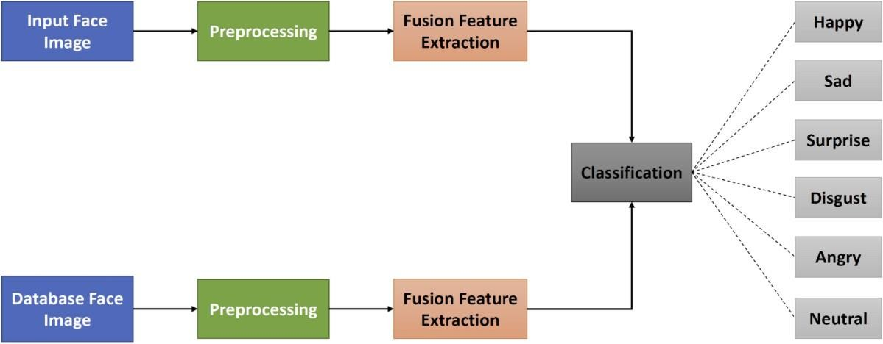

### DIG 3. BLOCK DIAGRAM FOR MUSIC SYSTEM USING FACE DETECTION

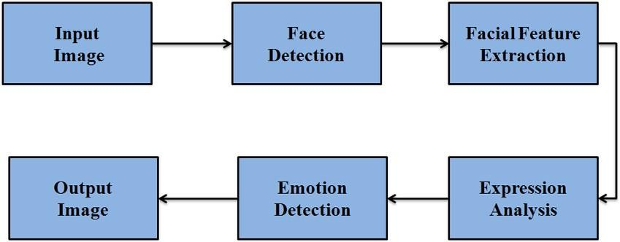

**DIG 4. BLOCK DIAGRAM FOR MUSIC SYSTEM USING FACE DETECTION**

## BLOCK DIAGRAMS OF WORKFLOW

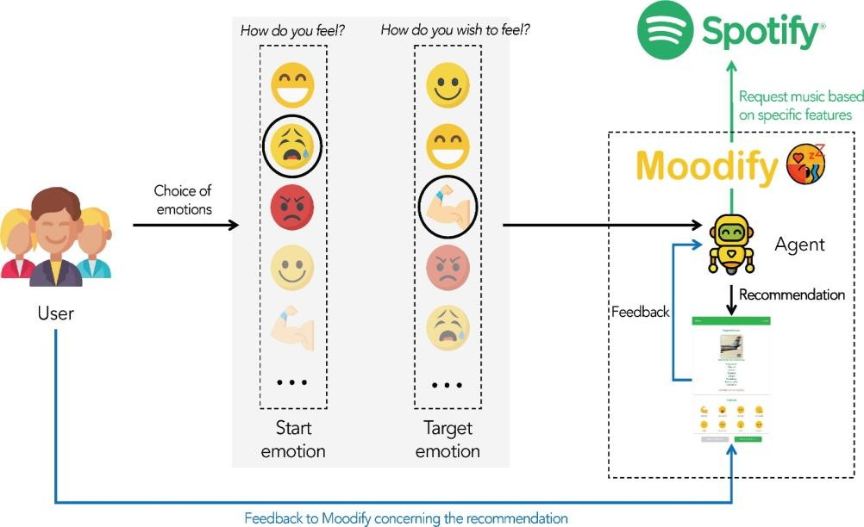

**DIG 5 . Music recommendation system using face detection workflow**

## Class Diagram

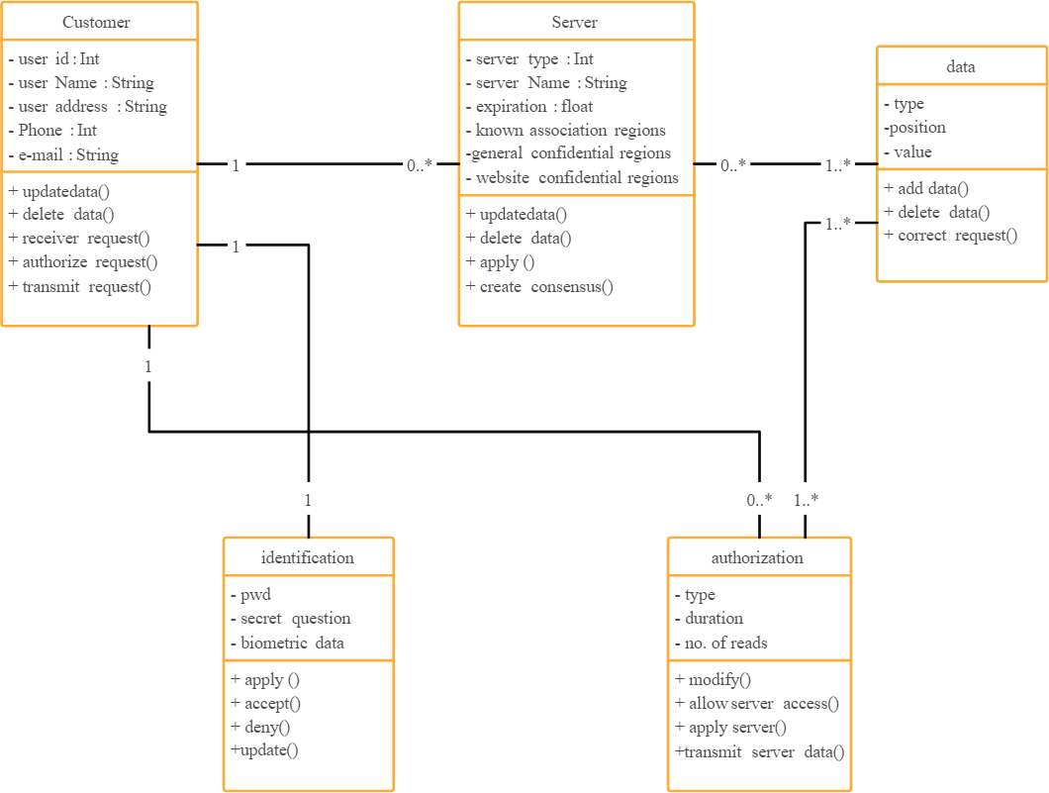

**DIG 6 . Class diagram of Music Recommendation System Using face detection**

## Sequence Diagram

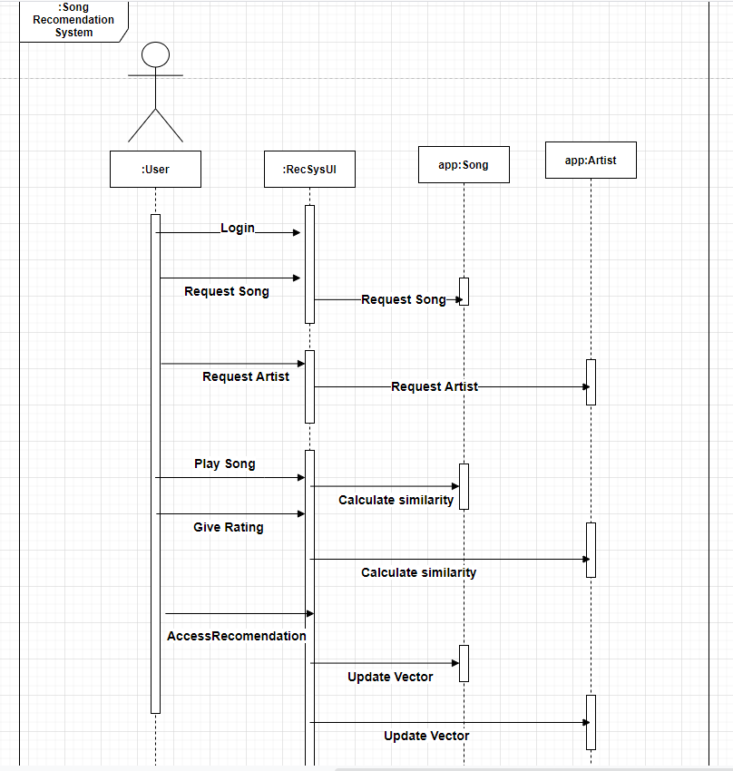

### DIG. 7 Block diagram of augmented reality model

**PROTOCOL**

Here's a possible protocol outline for a music recommendation system using face detection, incorporating the future advancements we discussed:

Data Acquisition and Preprocessing

User Consent: Obtain explicit user consent for facial data collection and usage, outlining data security measures.

Data Collection: Capture video streams using high-resolution cameras with proper lighting conditions.

Face Detection: Employ robust facial detection algorithms to accurately locate faces within each frame.

Emotion Detection: Utilize advanced deep learning models trained on a diverse emotional dataset, encompassing micro-expressions and nuanced emotions.

Physiological Data (Optional): Integrate sensors (with user consent) to collect heart rate and skin conductance data for a more comprehensive emotional picture.

Contextual Data Collection: Gather contextual information like time of day, activity level (through motion sensors), and social setting (through microphone analysis with privacy filters).

Multimodal Data Fusion and Emotion Recognition

Data Cleaning and Preprocessing: Clean and pre-process all collected data (facial, physiological, contextual) for consistency and compatibility.

Feature Extraction: Extract relevant features from each data type (facial landmarks, physiological signal patterns, temporal aspects from context).

Multimodal Fusion: Develop a fusion model that combines features from all data sources to create a richer emotional representation.

Emotion Classification: Train a machine learning model to classify the fused representation into user emotions with high accuracy.

Music Recommendation and Personalization

Genre-Mood Mapping: Establish a dynamic mapping between emotions, music genres, and individual songs based on user preferences and music databases. This mapping should adapt over time as user listening habits evolve.

User-Specific Calibration: Allow users to personalize the emotion-to-music mapping by providing feedback on recommendations.

Recommendation Generation: Based on the classified user emotion and personalized mapping, recommend a set of songs that best match the user's current state.

System Evaluation and Improvement

User Testing: Conduct user studies to evaluate the effectiveness and user satisfaction with the recommendation system.

A/B Testing: Implement A/B testing to compare different emotion detection, fusion, and recommendation algorithms, selecting the most performant ones.

Continuous Learning: Continuously update the system with new user data and music trends to improve recommendation accuracy and personalization.

Security and Ethics

Data Security: Implement robust data security measures like encryption and anonymization to protect user privacy.

Transparency and User Control: Provide users with clear information about data collection, usage, and storage practices. Allow users to control and delete their data at any time.

Bias Mitigation: Regularly monitor and address potential biases in facial recognition algorithms and music databases to ensure fair recommendations.

This protocol provides a foundational framework for a future-oriented music recommendation system using face detection. Remember, ethical considerations and user privacy are paramount throughout the process.

Recommendation Engine Protocols:

Caching and Data Freshness:

Define protocols for caching frequently accessed data (like genre-mood mappings or user preferences) to improve system responsiveness.

Establish data freshness policies to update cached data periodically or based on user activity to ensure recommendations reflect current preferences.

Diversity

Implement protocols to ensure recommendations include a mix of familiar genres/artists preferred by the user and new suggestions for exploration, promoting serendipitous discovery of music.

Define metrics to balance familiarity and novelty in recommendations based on user preferences or listening history.

Cold Start Problem:

Establish protocols to address the "cold start problem" for new users with limited data. This might involve using generic mood-based recommendations or incorporating demographic information (if user consent is obtained).

Develop strategies for gathering user data efficiently during initial interactions to personalize recommendations faster.

Explainability and Transparency:

Design protocols to provide users with some level of explanation for the music recommendations they receive. This could involve highlighting the emotions detected or the user preferences considered.

Define transparency measures to inform users about the overall recommendation process and the data sources used.

Offline Recommendations:

Develop protocols for generating music recommendations even when the user is not actively using the system (assuming user consent for background data processing). This could involve leveraging historical data or ongoing emotional detection through wearables (with proper privacy safeguards).

Establish protocols for storing and managing offline recommendations for later access by the user.

# 4 PERFORMANCE ANALYSIS

## TESTING

Testing in augmented reality (AR) involves evaluating and validating the functionality, performance,and user experience of AR applications or systems. Here are some key aspects and strategies for testing in augmented reality:

Feature Testing: Verify that all AR features and functionalities work as intended. Interaction Testing: Test how users interact with AR elements and ensure a seamless experience. Tracking and Recognition: Evaluate the accuracy and reliability of object tracking and imagerecognition.

Performance Testing:

Speed and Responsiveness: Assess the speed of rendering AR content and the responsiveness ofinteractions.

Resource Usage: Check the application's impact on device resources like CPU, GPU, and memory.Battery Life: Test the application's impact on the device's battery life.

Compatibility Testing:

Device Compatibility: Ensure that the AR application works across various AR- enabled devices. Operating System Compatibility: Verify compatibility with different operating systems and versions.Usability Testing:

User Interface (UI) and User Experience (UX): Evaluate the design, layout, and overall userexperience of AR interfaces.

Navigation and Controls: Test the effectiveness of navigation and control mechanisms in the ARenvironment.

Security Testing:

Data Privacy: Ensure that user data is handled securely and that the AR application adheres to privacyregulations.

Network Security: Verify the security of communication channels between the AR application andany connected servers.

Localization and Internationalization Testing:

Language Support: Test the AR application with different languages to ensure proper localization. Cultural Considerations: Evaluate how the AR content aligns with various cultural norms andsensitivities.

Stress Testing:

Load Testing: Evaluate how the AR application performs under heavy user loads. Environment Testing: Test the application in different real-world environments to assess itsrobustness.

Regression Testing:

Compatibility with Updates: Ensure that the AR application remains compatible with the latestupdates to operating systems or AR frameworks.

User Acceptance Testing (UAT):

Engage Real Users: Get feedback from actual users to assess their satisfaction and identify areas forimprovement.

10) Documentation

Testing Documentation: Maintain thorough documentation of test cases, results, and any issues encountered during testing.

Remember that testing AR applications often involves a combination of real-world testing and simulation, making it essential to consider various environmental factors. Additionally, ongoing testing and updates are crucial to keep the AR application in optimal condition as technology and userexpectations evolve.

Top of Form

We perform all the testing related website following Table 4.1 shows all the testing measures.

# 5 RESULT

Home page as System-Embrace the Sunshine!

A bright and cheerful background image showcases people enjoying music in a sunny outdoor setting.

Main Section: Smile for Happy Beats

Live Smile Detection: A small window with your webcam feed allows you to see yourself in real-time. Overlaid text might say "Big Smile Detected!" or "Feeling Sunny?" based on facial expression analysis.

Happy Hits Playlist: A dynamic playlist populated with song titles, artists, and colorful album artwork appears below the webcam window. This playlist updates as you smile, encouraging you to engage with the system.

Get Groovin! A prominent "Play Now!" button allows you to seamlessly play the recommended happy playlist on your preferred music streaming service (assuming it's linked).

Secondary Sections:

* Feeling Different? A discreet link leads to a page explaining the system can detect other emotions besides happiness in future updates.
* Explore More Happy: A row of buttons or icons showcases subgenres known for uplifting vibes (e.g., Dance Pop, Feel-Good Rock, Sunshine Reggae). This allows you to explore specific happy music styles.
* Happy Hits Radio: An option to play a curated radio station based on happy music, offering a continuous stream of uplifting tunes.

Trust and Transparency:

* Smile with Confidence: A link leads to a dedicated page explaining data privacy practices, user control over data, and anonymization techniques used to protect user information.
* Learn More: A link provides a short video explaining how facial expressions are used to recommend music, focusing on the positive and user-centric approach of the system.

Overall Design:

* Maintain a cheerful and inviting aesthetic. Use bright colors, playful fonts, and positive imagery throughout the homepage to reflect the focus on happy music.
* Keep the interface uncluttered and user-friendly with clear calls to action. Remember: This is a hypothetical example, and the actual design will depend on the specific developers and functionalities offered by the system

### Recommendation Result Of A System-

Emotions and Music Recommendations with Facial Detection Here's a breakdown of how facial expressions might be used to detect emotions and influence music recommendations:

### Emotions Detectable Through Facial Expressions:

**Happiness:** Wide smiles, raised eyebrows, furrowed brows around the eyes (crow's feet) **Sadness:** Downward-turned corners of the mouth, furrowed brows between the eyebrows, drooped eyelids

**Anger:** Frowning or furrowed brow, narrowed eyes, pursed lips, flared nostrils

**Surprise:** Raised eyebrows, widened eyes, open mouth

**Fear:** Wide eyes, raised eyebrows, open mouth, flared nostrils

**Disgust:** Wrinkled nose, raised upper lip, furrowed brow

**Contempt:** Smirking or sneering expression, pursed lips, raised one side of the

### Music Recommendations based on Emotions:

**Happy:** Upbeat, energetic music with positive lyrics (pop, dance, electronic) **Sad:** Slower, melancholic music with introspective lyrics (ballads, blues, folk) **Angry:** Loud, aggressive music with powerful vocals (rock, metal, punk)

**Surprise:** Uplifting or whimsical music with unexpected elements (electronic, pop) **Fear:** Suspenseful or dark music with building tension (soundtracks, orchestral) **Disgust:** Dissonant or jarring music (experimental, noise)

**Contempt:** Sarcastic or cynical music with critical lyrics (rock, hip-hop)

### Important Considerations:

**Emotional Complexity:** Facial expressions can be nuanced and influenced by cultural background or personal experiences. The system might need to consider additional factors like context or user preferences to improve accuracy.

**Music Genre Associations:** The association between emotions and music genres can be subjective. The system might benefit from user feedback to personalize these associations.

**Limited Scope:** Not all emotions are easily detectable through facial expressions. The system might need to be supplemented with other data sources (e.g., physiological sensors) for a more comprehensive picture.

**Overall,** using facial expressions for music recommendations offers an interesting approach. However, it's important to acknowledge the limitations and strive for a user- centric design that prioritizes privacy, transparency, and continuous improvement based on user feedback.

### Result updated steps followings -

**Step 1: Emotion Music Recommender with happy face-**

### Happiness: Wide smiles, raised eyebrows, furrowed brows around the eyes (crow's feet )

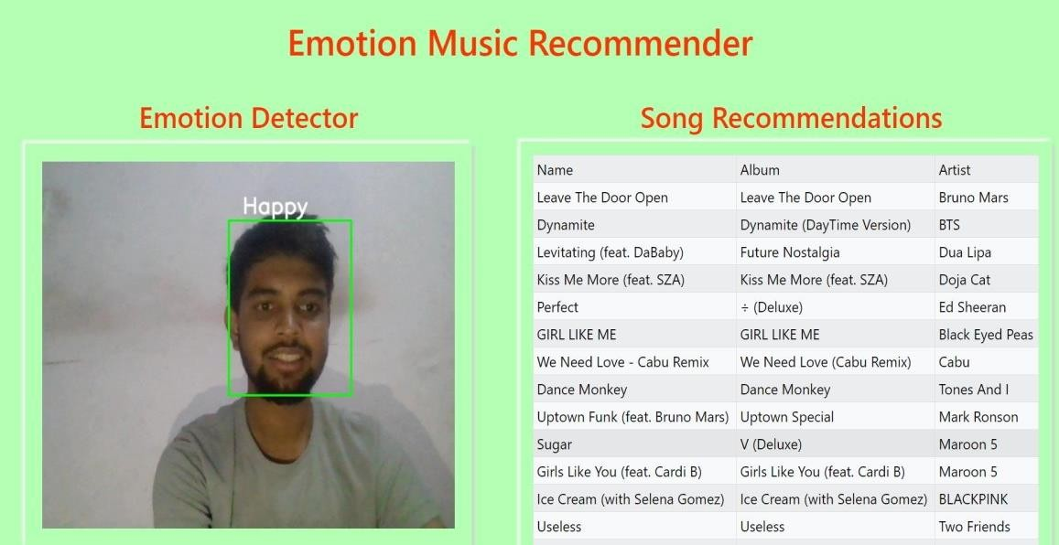

his system uses facial expressions, specifically detecting happy faces, to recommend music that uplifts your mood and keeps the good vibes flowing.

Here's a breakdown of the concept:

### Core Functionality:

A webcam captures your facial expressions. A machine learning model analyzes the video feed, focusing on recognizing happy expressions (wide smiles, raised eyebrows, etc.). Based on the detection of happiness, the system recommends music known to evoke positive emotions. This might include genres like pop, dance, or upbeat electronic music with cheerful lyrics.

### Benefits:

**Effortless Recommendations:** No need to manually choose a mood or genre. Just smile, and the system takes care of the rest.

**Mood Boost:** The recommended music can further elevate your mood, creating a positive feedback loop.

**Music Discovery:** You might discover new artists or songs that bring you joy.

**Step:2**

**Emotion Music Recommender with fearful fac. FEAR: Wide eyes, raised eyebrow ,mouth, flared nostril**

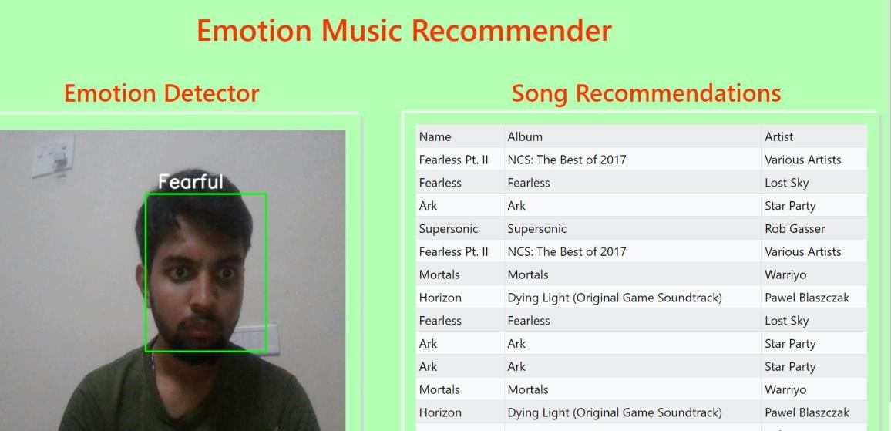

### Emotion Music Recommender with Fear Face

While a music recommendation system based solely on fear detection might not be ideal for everyday use, it could be adapted for specific purposes. Here's a breakdown of two potential approaches:

### Approach 1: Calming Music for Fearful Situations Core Functionality:

The system detects a fearful face through webcam analysis (wide eyes, raised eyebrows, open mouth).

Instead of recommending music that evokes fear, it suggests calming and soothing music to help the user relax. This could include genres like classical, ambient, or nature sounds.

### Benefits:

Offers stress relief and anxiety reduction in situations that might trigger fear (e.g., public speaking, turbulence on a flight).

Promotes relaxation and well-being.

### Step 03 : Emotion Music Recommender with sad face-

**Sadness: Downward-turned corners of the mouth, furrowed brows between the eyebrows, drooped eyelids**

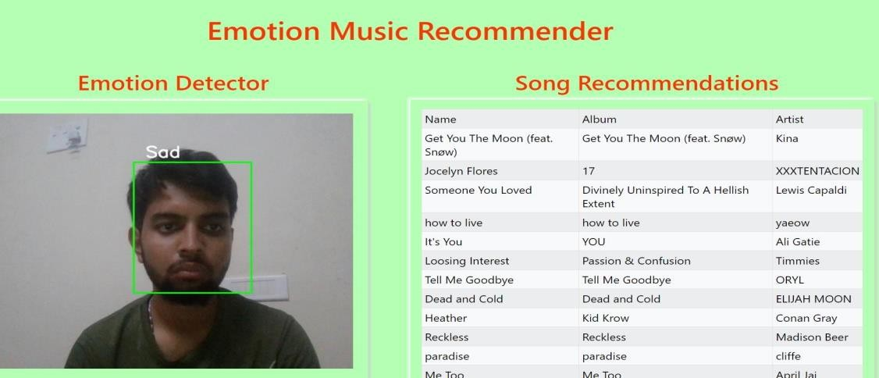

### Emotion Music Recommender with Sad Face

Here's a breakdown of a music recommendation system that uses a sad face to suggest music:

### Core Functionality:

A webcam captures your facial expressions.

A machine learning model analyzes the video feed, focusing on recognizing sadness Based on sadness detection, the system recommends music that can:

**Validate Emotions:** Slower, melancholic music with introspective lyrics can acknowledge

**Uplift Mood:** Upbeat or nostalgic music with positive messages can offer a gentle

### Benefits:

**Emotional Validation:** The system acknowledges your sadness and offers music that

**Mood Regulation:** Depending on your preference, the system can either provide

.

### Step 04:-

**Emotion Music Recommender with Angry face-**

**Anger: Frowning or furrowed brow, narrowed eyes, pursed lips, flared nostrils**

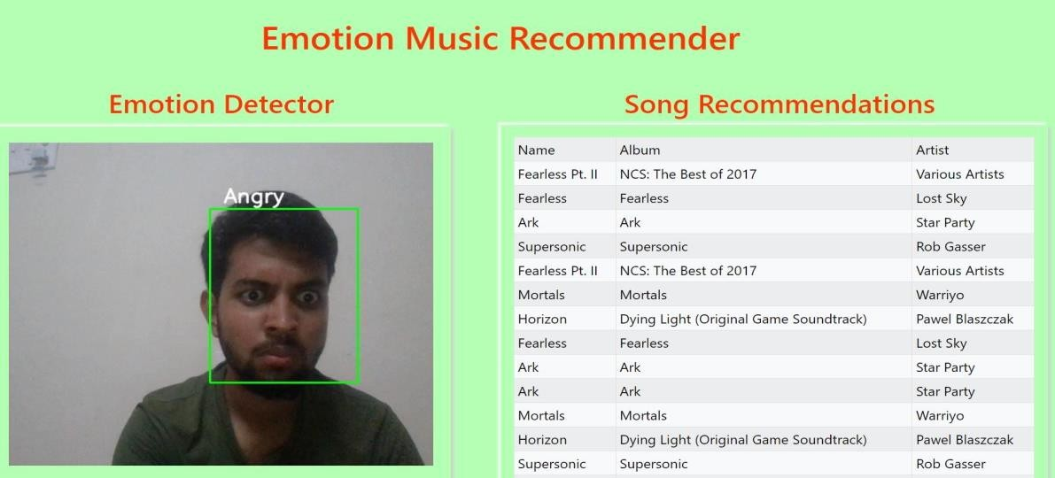

**Emotion Music Recommender with Angry Face**

Here's a breakdown of a music recommendation system that uses an angry face to trigger music recommendations:

### Core Functionality:

A webcam captures your facial expressions.

A machine learning model analyzes the video feed, focusing on recognizing angry expressions (frowning, furrowed brows, narrowed eyes, pursed lips).

Based on anger detection, the system recommends music that can be:

**Cathartic:** High-energy, aggressive music that allows you to release pent-up emotions in a healthy way (e.g., rock, metal, punk).

**Calming:** Soothing music to help you de-escalate and manage anger (e.g., classical, ambient).

### Benefits:

**Emotional Release:** Cathartic music can provide a healthy outlet for expressing anger. **Stress Reduction:** Music can help manage anger and potentially reduce stress levels. **Mood Regulation:** The system can offer options to either release or calm your emotions through music sel

**Step 5: Emotion Music Recommender with surprised face- Surprise: Raised eyebrows, widened eyes, open mouth**

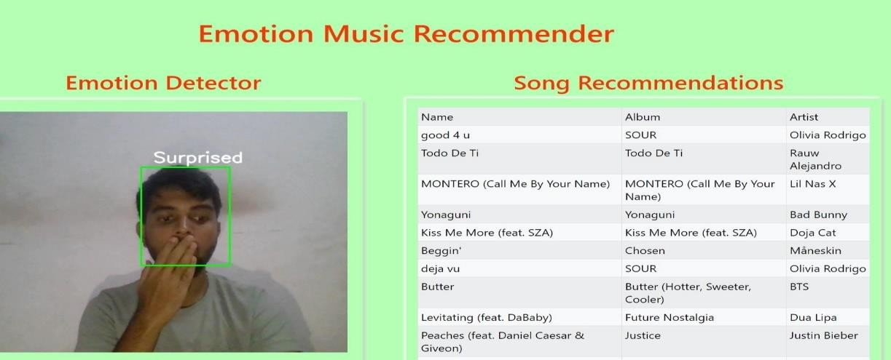

**Emotion Music Recommender with Surprised Face**

Here's a breakdown of a music recommendation system that uses a surprised face to trigger recommendations:

### Core Functionality:

A webcam captures your facial expressions.

A machine learning model analyzes the video feed, focusing on recognizing surprised expressions (raised eyebrows, widened eyes, open mouth).

Based on surprise detection, the system recommends music that might pique your curiosity or introduce you to new genres. This could include unexpected musical styles, experimental artists, or exciting remixes.

### Benefits:

**Music Discovery:** The system encourages exploration of unfamiliar music that might surprise and delight you.

**Breaking Routine:** If you're stuck in a musical rut, the surprise recommendations can introduce you to fresh sounds and broaden your musical horizons.

**Intrigue and Excitement:** The element of surprise adds a fun and interactive twist to music discovery.

pen_spark

### 5.1 Tentative Project Timeline-

A tentative time schedule of research work planned is given**:**

|  |  |  |
| --- | --- | --- |
| **Sr.**  **No.** | **Research Activity** | **Schedule** |
| 1 | Collecting Databases and Design of Tentative Module | 28/08/2023 |
| 2 | **Mini-I Review 1** – **Presentation** | 12/09/2023 |
| 3 | Implementation and Design of Algorithms and Modules 20% To 30% | 20/10/2023 |
| 4 | **Mini-I Review 2** – **Presentation** | 10/11/2023 |
| 5 | Results Comparisons and Testing ofWhole Projects | 5/12/2023 |
| 6 | Report Write-Up, Revision and  Correction | 5/12/2023 |
| 7 | **Mini-II Review 1 – Presentation** | 9/03/2024 |
| 8 | Module 2 execution [60% work done] | 12/04/2024 |
| 9 | Full Project completion [100% work  done] | 17/05/2024 |
| 10 | **Mini-II Review 2 - Presentation** | 17/05/2024 |
| 11 | Submission of Report | 7/06/2024 |
| 12 | Submission of Published Paper | 7/6/2024 |

# 6 CONCLUSION

In conclusion, the project on personalized online learning platform recommendation using machine learning represents a significant advancement in the field of educational technology. By leveraging machine learning algorithms and personalized recommendation techniques, the project aims to enhance the learning experience for users on online learning platforms by providing tailored recommendations that cater to individual preferences, learning styles, and goals. Throughout the course of the project, various methodologies, algorithms, and techniques have been explored and implemented to develop an effective recommendation system. From data collection and preprocessing to feature extraction, model training, and evaluation, each step has been carefully orchestrated to ensure the accuracy, relevance, and usability of the recommendation system. The results of the project demonstrate the efficacy of personalized recommendations in improving user engagement, satisfaction, and learning outcomes on the online learning platform.

By analyzing user behavior, content characteristics, and contextual information, the recommendation system can deliver targeted recommendations that resonate with users and facilitate their learning journey.

Facial emotion detection: The user's face is captured via a webcam or image, and their emotion is predicted using a pre-trained deep learning model like CNN. Common emotions detected include happy, sad, angry, surprised, fearful, disgusted, and Music mood prediction: Songs in a dataset are pre-classified into moods like happy, sad, energetic Content-based filtering: For a detected user emotion, the system retrieves songs with matching moods from the dataset. It generates a playlist vector and uses cosine similarity to recommend the top songs that best fit the user's current mood Playlist generation:

he recommended songs are compiled into a playlist and played for The system can also learn from the user's feedback to refine future recommendations By automating the process of finding mood-appropriate music, such a system can help reduce provide entertainment, and enhance the user's listening experience. The use of facial expressions as input makes the recommendations more intuitive and personalized compared to manual playlist curation.

### APPLICATIONS

Here are some potential applications for a music recommendation system using facial emotion recognition:

### Personalized music streaming

the facial emotion detection and music recommendation into a music streaming app or Integrate website

Automatically generate personalized playlists for users based on their real-time mood

Provide an engaging and adaptive listening experience that evolves with the user's changing emotions

### Mood-based music therapy

Use the system in clinical settings for music therapy to help patients manage their emotions and mental health

Recommend soothing or uplifting music based on the patient's detected mood and emotional state

Track the patient's emotional progress over time through the music recommendations

### Mood-aware smart speakers

Incorporate the facial emotion recognition into smart speakers like Amazon Echo or Google Home

Detect the user's mood when they interact with the speaker and recommend appropriate music Provide a more natural and intuitive music experience through voice commands and facial expression.

### Mood-based music playlists for events

Use the system to generate mood-appropriate music playlists for events like weddings, parties, or corporate functions

Detect the overall mood of the crowd through facial expressions captured by cameras Automatically adjust the playlist to keep the audience engaged and entertained based on their collective mood

### Mood-based much for gaming and VR

Integrate the facial emotion recognition into gaming consoles or VR headsets Detect the player's mood during gameplay and adjust the background music accordingly

Enhance the immersion and emotional impact of the gaming experience through adaptive music These applications demonstrate the potential of using facial emotion recognition to create more personalized, adaptive, and engaging music experiences tailored to the user's mood and emotional Other Application for music recommendation system using face detection-

### Mood-based Music for Fitness and Exercise

Integrate the facial emotion recognition into fitness apps or exercise equipment Detect the user's mood during exercise and adjust the music playlist accordingly Enhance the workout experience by providing music that matches the user's emotional state and energy level

### Emotion-based Music for Mental Health and Therapy

Use the system in mental health clinics or therapy sessions

Detect the patient's mood and provide music recommendations to help manage their emotions Enhance the therapeutic experience by providing personalized music recommendations tailored to the patient's emotional state

### Mood-aware Music for Events and Parties

Use the facial emotion recognition in event planning and management Detect the mood of the crowd and adjust the music playlist accordingly

Enhance the event experience by providing music that matches the collective mood of the attendees

### Personalized Music for Travel and Tourism

Integrate the facial emotion recognition into travel apps or tourist guides Detect the traveler's mood and provide music recommendations based on their emotional Enhance the travel experience by providing personalized music recommendations tailored to the traveler's mood and preferences

### Mood-based Music for Gaming and Virtual Reality

Use the facial emotion recognition in gaming consoles or VR headsets

Detect the player's mood during gameplay and adjust the music playlist accordingly Enhance the gaming experience by providing music that matches the player's emotional state and enhances the immersive experience

### Emotion-based Music for Education and Learning

Use the facial emotion recognition in educational settings or learning platforms Detect the student's mood and provide music recommendations based on their emotional state Enhance the learning experience by providing personalized music recommendations tailored to the student's mood and learning style

### Mood-aware Music for Healthcare and Rehabilitation

Use the facial emotion recognition in healthcare settings or rehabilitation centers Detect the patient's mood and provide music recommendations to help manage their emotions Enhance the healthcare experience by providing personalized music recommendations tailored to the patient's emotional state and medical needs

**6.2.FUTURE SCOPE**

Music recommendation systems using face detection have the potential to become more sophisticated and nuanced in the future. Here are some areas of exploration:

Improved Emotion Detection:

Beyond Basic Emotions: Current systems typically focus on basic emotions like happy, sad, angry, etc. Future systems could incorporate more complex emotions and user-specific interpretations of music.

Micro-Expressions and Subtle Cues: Facial expressions can be fleeting. New techniques might capture micro-expressions and subtle cues to better understand emotional states.

Multimodal Data Fusion:

Physiological Data: Integrating data from physiological sensors (heart rate, skin conductance) could provide a more holistic picture of user emotions.

Contextual Information: Consideration of factors like time of day, activity level, and social context could refine recommendations.

Genre and Mood Mapping:

Genre Specificity: Refining the mapping between emotions, genres, and individual songs for more accurate recommendations.

User-Specific Preferences: Learning individual user preferences for how emotions translate to music choices.

Applications Beyond Music:

Mental Health Management: Recommending music to improve mood or manage stress. Personalized Advertising: Tailoring advertisements based on user emotions detected through facial recognition.

Ethical Considerations:

Privacy Concerns: Ensuring user privacy and transparency in data collection and usage will be crucial.

Bias and Fairness: Mitigating potential biases in facial recognition algorithms and music databases.

Overall, face detection for music recommendation has promise, but technical and ethical challenges need to be addressed for widespread adoption.

## REFERENCES

1. Koren, Y., Bell, R., & Volinsky, C. (2009). Matrix factorization techniques for recommender systems. Computer, 42(8), 30-37.
2. Ricci, F., Rokach, L., & Shapira, B. (2015). Introduction to recommender systems handbook. In Recommender Systems Handbook (pp. 1-35). Springer, Boston, MA.
3. Adomavicius, G., & Tuzhilin, A. (2005). Toward the next generation of recommender systems: A survey of the state-of-the-art and possible extensions. IEEE Transactions on Knowledge and Data Engineering, 17(6), 734-749.
4. Burke, R. (2002). Hybrid recommender systems: Survey and experiments. User Modeling and User-Adapted Interaction, 12(4), 331-370.
5. Tan, P. N., Steinbach, M., & Kumar, V. (2013). Introduction to Data Mining. Pearson Education
6. Bengio, Y., Courville, A., & Vincent, P. (2013). Representation learning: A review and new perspectives. IEEE Transactions on Pattern Analysis and Machine Intelligence, 35(8), 1798- 1828.Konstan, J. A., Miller, B. N., Maltz, D., Herlocker, J. L., Gordon, L. R., & Riedl, J. (1997). GroupLens: Applying collaborative filtering to Usenet news. Communications of the ACM, 40(3), 77-87.
7. Sarwar, B., Karypis, G., Konstan, J., & Riedl, J. (2001). Item-based collaborative filtering recommendation algorithms. In Proceedings of the 10th International Conference on World Wide Web (WWW '01), 285-295. He, X., Liao, L., Zhang, H., Nie, L.,
8. Hu, X., & Chua, T. S. (2017). Neural collaborative filtering. In Proceedings of the 26th International Conference on World Wide Web (WWW '17), 173-182.
9. Wu, Y., DuBois, T., Zheng, A. X., & Ester, M. (2016). Collaborative denoising auto- encoders for top-n recommender systems. In Proceedings
10. Fathima, A. Jainul and K. Vaidehi. “Review on Facial Expression Recognition System Using Machine Learning Techniques.” Learning and Analytics in Intelligent Systems (2019): n. pag.
11. Bhatti, Yusra Khalid et al. “Facial Expression Recognition of Instructor Using Deep Features and Extreme Learning Machine.” Computational Intelligence and Neuroscience 2021 (2021): n. pag.
12. Saurav, Sumeet et al. “Facial Expression Recognition Using Dynamic Local Ternary Patterns With Kernel Extreme Learning Machine Classifier.” IEEE Access 9 (2021): 120844- 120868.
13. Mahmud, Firoz and Al-Amin Mamun. “Facial Expression Recognition System Using Extreme Learning Machine.” (2017).
14. Srinivasa Rao, C., Tilak Babu, S.B.G. (2016). Image Authentication Using Local Binary Pattern on the Low Frequency Components. In: Satapathy, S., Rao, N., Kumar, S., Raj, C., Rao, V., Sarma, G. (eds) Microelectronics, Electromagnetics and Telecommunications. Lecture Notes in Electrical Engineering, vol 372. Springer, New Delhi. [https://doi.org/10.1007/978-81-](https://doi.org/10.1007/978-81-322-2728-1_49) [322-2728-1_49](https://doi.org/10.1007/978-81-322-2728-1_49)
15. 6.Lencioni, Gabriel Carreira et al. “Pain assessment in horses using automatic facial expression recognition through deep learning-based modeling.” PLoS ONE 16 (2021): n. pag.
16. Roland Aigner, Andreas Pointner, Thomas Preindl, Rainer Danner, and Michael Haller. 2021. TexYZ: Embroidering Enameled Wires for Three DegreeofFreedom Mutual Capacitive Sensing. In Proceedings of the 2021 CHI Conference on Human Factors in Computing Systems (Yokohama, Japan) (CHI ’21). Association for Computing Machinery, New York, NY, USA,

Article 499, 12 page

1. Ozgur Atalay. 2018. Textile-based, interdigital, capacitive, soft-strain sensor for wearable applications. Materials 11, 5 (2018), 768. https://doi.org/10.3390/ ma11050768
2. James R Averill. 1999. Individual differences in emotional creativity: Structure and correlates. Journal of personality 67, 2 (1999), 331–371.
3. John N Bassili. 1979. Emotion recognition: the role of facial movement and the relative importance of upper and lower areas of the face. Journal of personality and social psychology 37, 11 (1979), 2049.
4. Dario Bombari, Petra C Schmid, Marianne Schmid Mast, Sandra Birri, Fred W Mast, and Janek S Lobmaier. 2013. Emotion recognition: The role of featural and configural face information. Quarterly Journal of Experimental Psychology 66, 12 (2013), 2426–2442.
5. Leah Buechley and Michael Eisenberg. 2009. Fabric PCBs, Electronic Sequins, and Socket Buttons: Techniques for e-Textile Craft. Personal Ubiquitous Comput. 13, 2 (feb 2009), 133–150. <https://doi.org/10.1007/s00779-007-0181-0>
6. Claus-Christian Carbon. 2020. Wearing face masks strongly confuses counterparts in reading emotions. Frontiers in psychology 11 (2020), 566886.
7. Chih-Chung Chang and Chih-Jen Lin. 2011. LIBSVM: A Library for Support Vector Machines. ACM Trans. Intell. Syst. Technol. 2, 3, Article 27 (may 2011), 27 pages. <https://doi.org/10.1145/1961189.1961199>
8. Tuochao Chen, Yaxuan Li, Songyun Tao, Hyunchul Lim, Mose Sakashita, Ruidong Zhang, Francois Guimbretiere, and Cheng Zhang. 2021. NeckFace: Continuously Tracking Full Facial Expressions on Neck-Mounted Wearables. Proc. ACM Interact. Mob. Wearable Ubiquitous Technol. 5, 2, Article 58 (jun 2021), 31 pages. https: //doi.org/10.1145/3463511